**Villena, Clifford T.**

**2nd Year – BSIT**

**Data Structure and Algorithm**

1. Write a java program that will ask a number from a user and identify what is the equivalent month of the number using a switch case statement. If the number entered is not 1 to 12, program will display n is not a month.

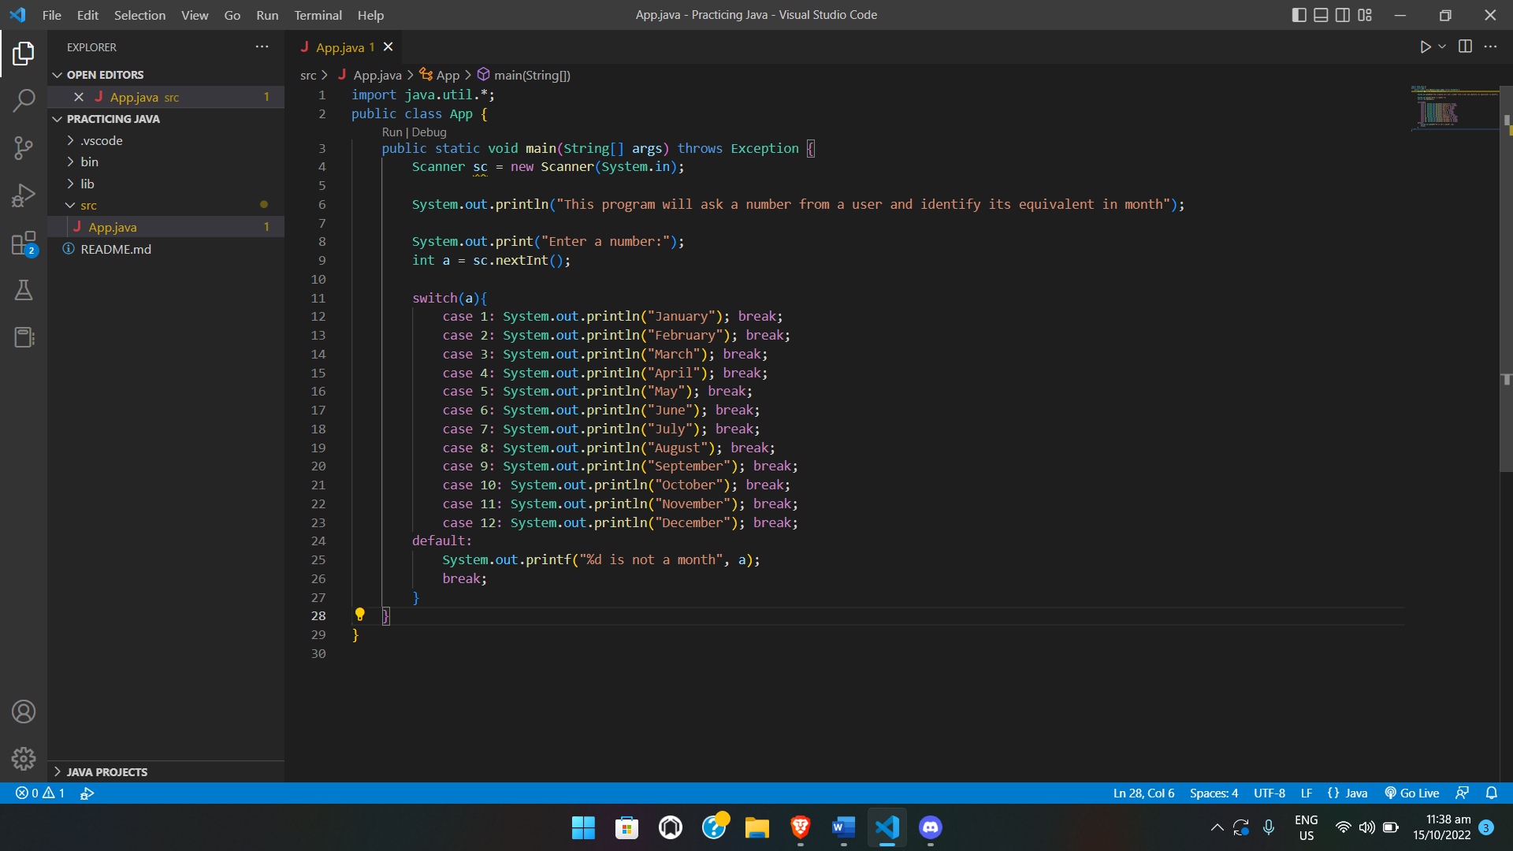

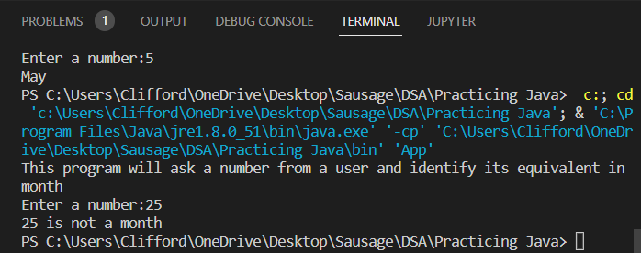

1. Write a java program that will ask for a letter input from the user and output the grade range based on the conditions indicated below using a switch case statement. If the letter is not within A – D, program should output Out of range

A = 90 – 100

B = 80 – 89

C = 70 – 79

D = 60 – 69

